Week2 Module2 Assignment2
In this assignment, I worked on designing and implementing a relational database schema using PostgreSQL. The task involved working with two datasets related to nutrient descriptions and nutrient values. By creating tables, loading data, and running SQL queries, I gained practical understanding of how relational databases are structured and used in real-world scenarios.
1. Record Structure Identification
A. Data Types
The datasets use different types of data to store information. Integer data types are used for fields like nutrient codes and food codes because they represent numeric identifiers. Float data types are used for nutrient values since they can store decimal values. Text-based fields such as nutrient description and unit are stored using VARCHAR data types, which allow flexible string storage.
B. Attributes and Purpose
Each dataset contains specific attributes. The nutrient description dataset includes attributes like nutrient code, nutrient description, and unit. These define what each nutrient is and how it is measured. The nutrient values dataset includes attributes such as Cn Code, nutrient code, and nutrient value. These represent the actual measured values of nutrients for different food items.
C. Boundaries
The boundaries of the data include limits such as the maximum length of text fields and the valid ranges for numeric values. For example, nutrient values must be within a realistic numeric range, and text fields should not exceed their defined length. These boundaries ensure data consistency and prevent errors.
2. Relational Schema Design
The schema was designed using two tables: nutdes and nutval. The nutdes table stores nutrient descriptions, while the nutval table stores nutrient values. Both tables are connected using the "Nutrient code" column, which acts as a common link between them. This relationship allows us to join the tables and perform combined queries.
3. Support of Schema by Record Structure
The record structure supports the schema design because the data types and attributes are consistent across both tables. The shared nutrient code allows efficient joins, while the use of appropriate data types ensures accurate storage and retrieval. This design makes it easy to query specific nutrients such as protein and analyze their values.
4. Schema Implementation
The schema was implemented in PostgreSQL using DBeaver. A new database named nutrient_db2 was created. Then, SQL commands were used to create the nutdes and nutval tables with appropriate columns and data types. This step ensured that the database structure was ready for data loading.
5. ETL Process
The ETL process involved three steps. First, the data was extracted from the provided CSV files. Next, the data was transformed by ensuring that the columns matched the table structure. Finally, the data was loaded into the database using DBeaver’s import feature. This allowed both datasets to be stored in the database successfully.
6. Query Execution and Verification
After loading the data, the provided SQL query was executed to verify that both tables were properly integrated. The query joined the nutdes and nutval tables based on nutrient code and filtered the results for protein values greater than 20. The output confirmed that the data was loaded correctly.
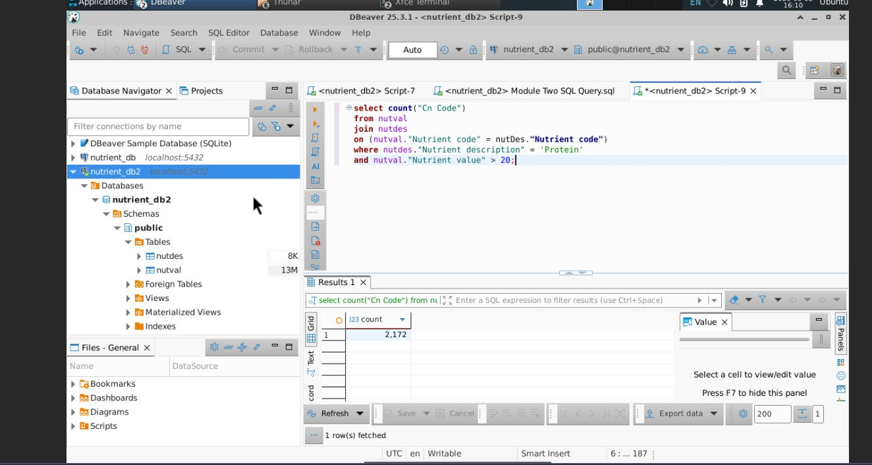
7. Database Backup
A backup of the database was created using the pg_dump tool. This backup file contains both the schema and the data, making it useful for recovery or version control. The file was then uploaded to a GitHub repository as required.
